Multilingual Emotion Detection
  - Project implementation and training review
Compiler Design | 23 October 2026
Advay Vivek | 24BCT0136
Kaavish Gogia | 24BCT0103
CodeMood Sarcasm Aware Hinglish Analysis
Review snapshot: 22 October 2026

Project architecture
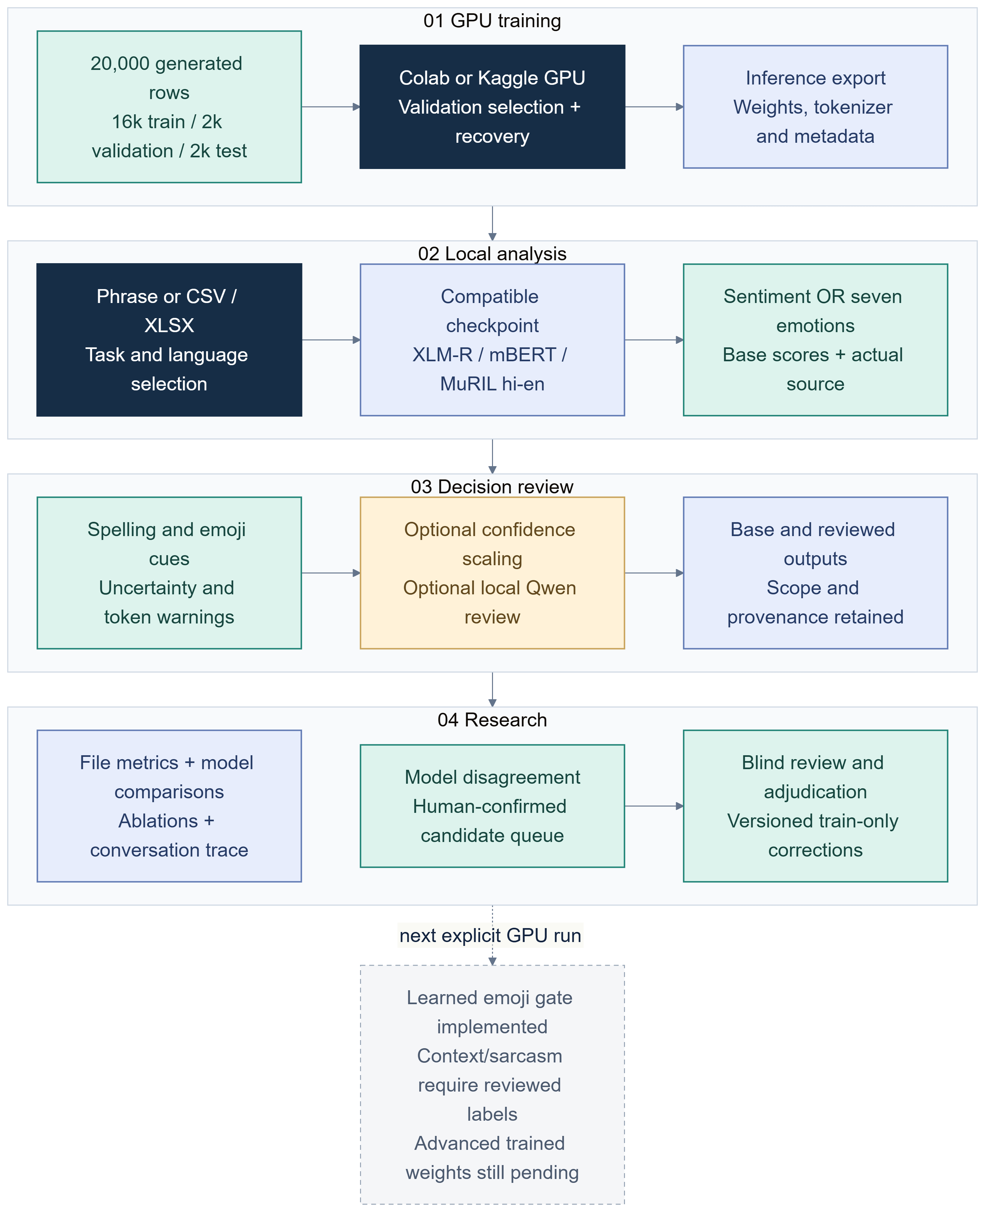
Figure 1. Project master map.

1 Executive summary
CodeMood is a local research workbench for phrase-level sentiment and seven-class emotion analysis of informal, code-mixed text. It combines a Streamlit application, command-line tools, installed multilingual checkpoints, reproducible training packages, file evaluation, provenance checks and a human-controlled review workflow. Its practical research question is how to build a traceable analysis pipeline for Hinglish while separating a usable prototype from evidence of real-world accuracy.
The strongest verified task result is the combined XLM-R checkpoint: 92.5% accuracy and 0.9251 macro-F1 on 2,000 generated test phrases, with 95.6%/0.9563 on the 1,000-row Hindi-English slice and 89.4%/0.8937 on the English-French slice. These are synthetic-only metrics. They show that training, export, installation and evaluation work on the recorded generated split. They do not establish accuracy on naturally authored messages. Four checkpoints spanning three encoder families are available for comparative diagnostics: original XLM-R, combined XLM-R, mBERT and MuRIL.
Implemented since the earlier project report are an experimental temperature-calibration workflow; paired input and reviewer ablation tooling; a bounded conversation trace interface; a two-reviewer correction-dataset handoff; and an optional XLM-R text-plus-emoji architecture. Their implementation status is not equivalent to a completed research result. No independently annotated human dataset was supplied for this review. The advanced fusion model has no trained checkpoint. New GPU training remains pending. Challenge phrases were assistant-authored diagnostic fixtures, not human ground truth.

2 Scope and evidence rules
This review asks four questions: what software and artifacts are present; what recorded scores show on their stated test sets; which new workflows support better evaluation and controlled training; and what evidence is still required before claiming robust emotion or sarcasm analysis.
Four evidence categories are used. Implemented means code and an interface or callable workflow exist. Experiment completed means a saved model, run record or measured output exists. Diagnostic means an observed example or challenge-set result helps identify failure modes but cannot support a population claim. Pending means required human labels, GPU execution or controlled comparison is absent. This distinction prevents a diagram from implying that every route has trained weights.
The project separates three-class sentiment (positive, neutral, negative) from seven-class emotion (joy, sadness, anger, fear, surprise, disgust, neutral). Their label spaces and checkpoints are distinct. Sarcasm is an experimental auxiliary task, not an established capability. A model’s highest softmax score is not a calibrated probability of correctness, emotional intensity, psychological state or evidence about a person.
The evaluation unit in this snapshot is a phrase row. That choice is useful for checking a classifier pipeline, but it does not represent the full social context in which Hinglish is written. A short message may depend on an earlier turn, an implied speaker, a quoted person, or a local convention around emoji. Conversely, collecting many rows from one author or template family can make a nominally large test set less independent than its row count suggests. Future dataset design should therefore track author-safe groupings or conversation identifiers where appropriate, and keep related paraphrases together across splits.
The central comparison is descriptive rather than inferential. The saved metrics provide point estimates on specific fixed synthetic test files; this report does not claim confidence intervals, statistical significance, or broad language coverage. Macro-F1 is included because it gives each class equal weight, while accuracy reflects total correctness on the observed rows. Both metrics are sensitive to the test distribution and label conventions. Per-class support and confusion matrices should accompany any future human-study score so that a single aggregate cannot hide a weak emotion category.
The supplied reference report describes BERT/RoBERTa, English-Hinglish emotion, Emoji2Vec fusion and confidence-based intensity wording. Its code excerpts report three-class sentiment results, including 95.7% English and 59.5% Hinglish for BERT. Those numbers are reference-document claims, not reproduced measurements here. CodeMood does not claim to reproduce a learned Emoji2Vec network. Earlier emoji support was primarily text retention and rule diagnostics; the new fusion implementation is optional and untrained.
The distinction matters because a shared encoder family or an emoji-aware interface does not make the experiment equivalent to the reference. The reference's reported sentiment labels and sample construction differ from CodeMood's seven emotion classes and generated multilingual splits. A percentage is meaningful only with its task, test rows, label mapping, preprocessing and split policy. The report therefore preserves the prior numbers as lineage context and reserves comparative evidence for matched data and protocol.

3 System map
The application follows a local-first path. A user chooses task, language scope and input. The selected checkpoint is checked against task labels and metadata. An unavailable or incompatible model is not silently downloaded or trained. Phrase prediction, batch prediction, file evaluation and diagnostic views produce outputs with model identity, warnings and data scope. Human review can export candidate labels only after explicit review; it does not update installed weights.
Three evidence boundaries matter. A demo rule can illustrate interface behavior but is not a model vote. A trained checkpoint can produce repeatable outputs but still lack natural-language validation. A human-reviewed row can supply a candidate training label but does not make a whole dataset representative. Data hashes, split manifests and overlap checks improve traceability; they do not certify label quality, authorship or semantic independence.
The repository also contains research tools beyond the dashboard. The experiments workbench compares input variants and optional reviewer modes. Calibration fits an experimental temperature profile from held-out rows. Conversation analysis presents a bounded sequence with context provenance. An advanced GPU trainer can optimize a text encoder, learned emoji representation and residual gate, with optional context and sarcasm supervision. Context mode and the auxiliary sarcasm head are disabled when their required labels are unavailable.

4 Phrase inference and diagnostics
For seven-emotion inference, the user selects Hindi-English or English-French, enters a phrase, and can supply earlier context or invoke a local reviewer. The detector returns a primary label, seven base scores, checkpoint identity, truncation and source warnings. Separate heuristics may flag uncertain margins or lexical/emoji conflict. These signals remain distinct: disagreement, uncertainty and correctness are not synonyms.
The optional reviewer can suggest a second label. Primary-model scores remain attached to the base prediction; a reviewer suggestion is not ground truth. The conversation view can track a short sequence and speaker-specific changes, but the model operates phrase by phrase. This is not a trained temporal encoder.
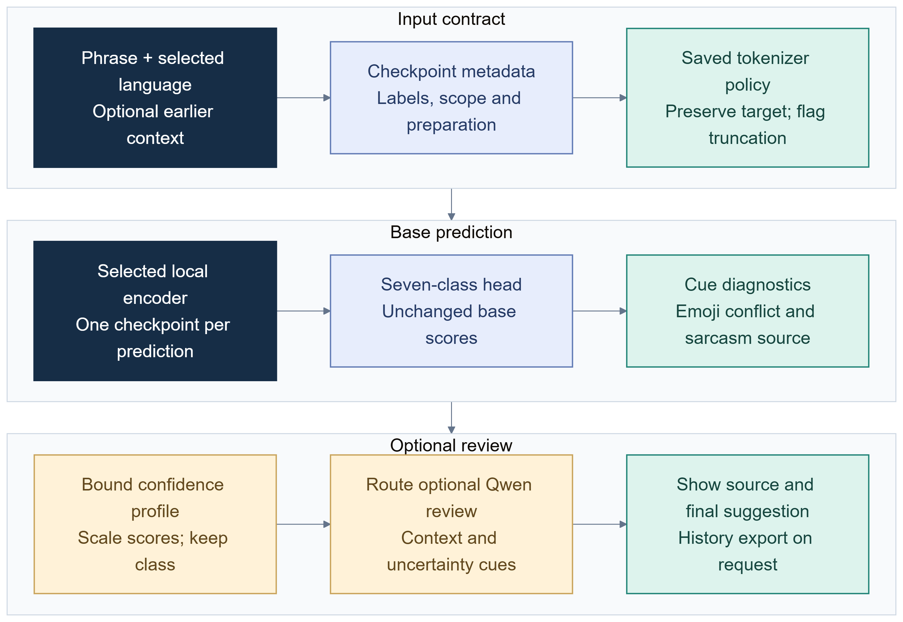
Figure 2. Inference, conversation and diagnostics.
A manually checked mBERT example exposed a high-confidence error: “Aaj main bahut khush hoon” was predicted as sadness at 99.94%. This is a diagnostic example, not a frequency estimate. It shows why a high score must not be described as certainty. Four model checkpoints may agree on some phrases and disagree on others; agreement alone still cannot establish correctness.
Qwen-style review is optional and local through Ollama. The call path has been exercised, but comparative benefit is unmeasured. Selective review should eventually be evaluated against no review and review-all using the same independently labelled examples, reporting both quality and coverage/latency. Reviewer output is an additional suggestion, not replacement annotation.

5 Training and recovery workflow
The completed multilingual training packages use pretrained encoders with a seven-output classification head. Combined XLM-R and mBERT use 16,000 training, 2,000 validation and 2,000 test examples. MuRIL and the original XLM-R pilot use 8,000/1,000/1,000. These are generated templates. Split manifests and hashes make reruns auditable; they do not turn generated text into natural messages.
Colab and Kaggle notebooks support GPU execution, validation-based checkpoint selection and model export. Recovery artifacts preserve completed-epoch state where configured. Exported inference packages contain weights, tokenizer/configuration and metadata; they omit optimizer state and raw test phrases. The working default is a seven-emotion text-only run. The advanced workflow can add an emoji gate and, only when appropriate independently reviewed labels exist, context or sarcasm objectives. Context and sarcasm supervision are off by default.
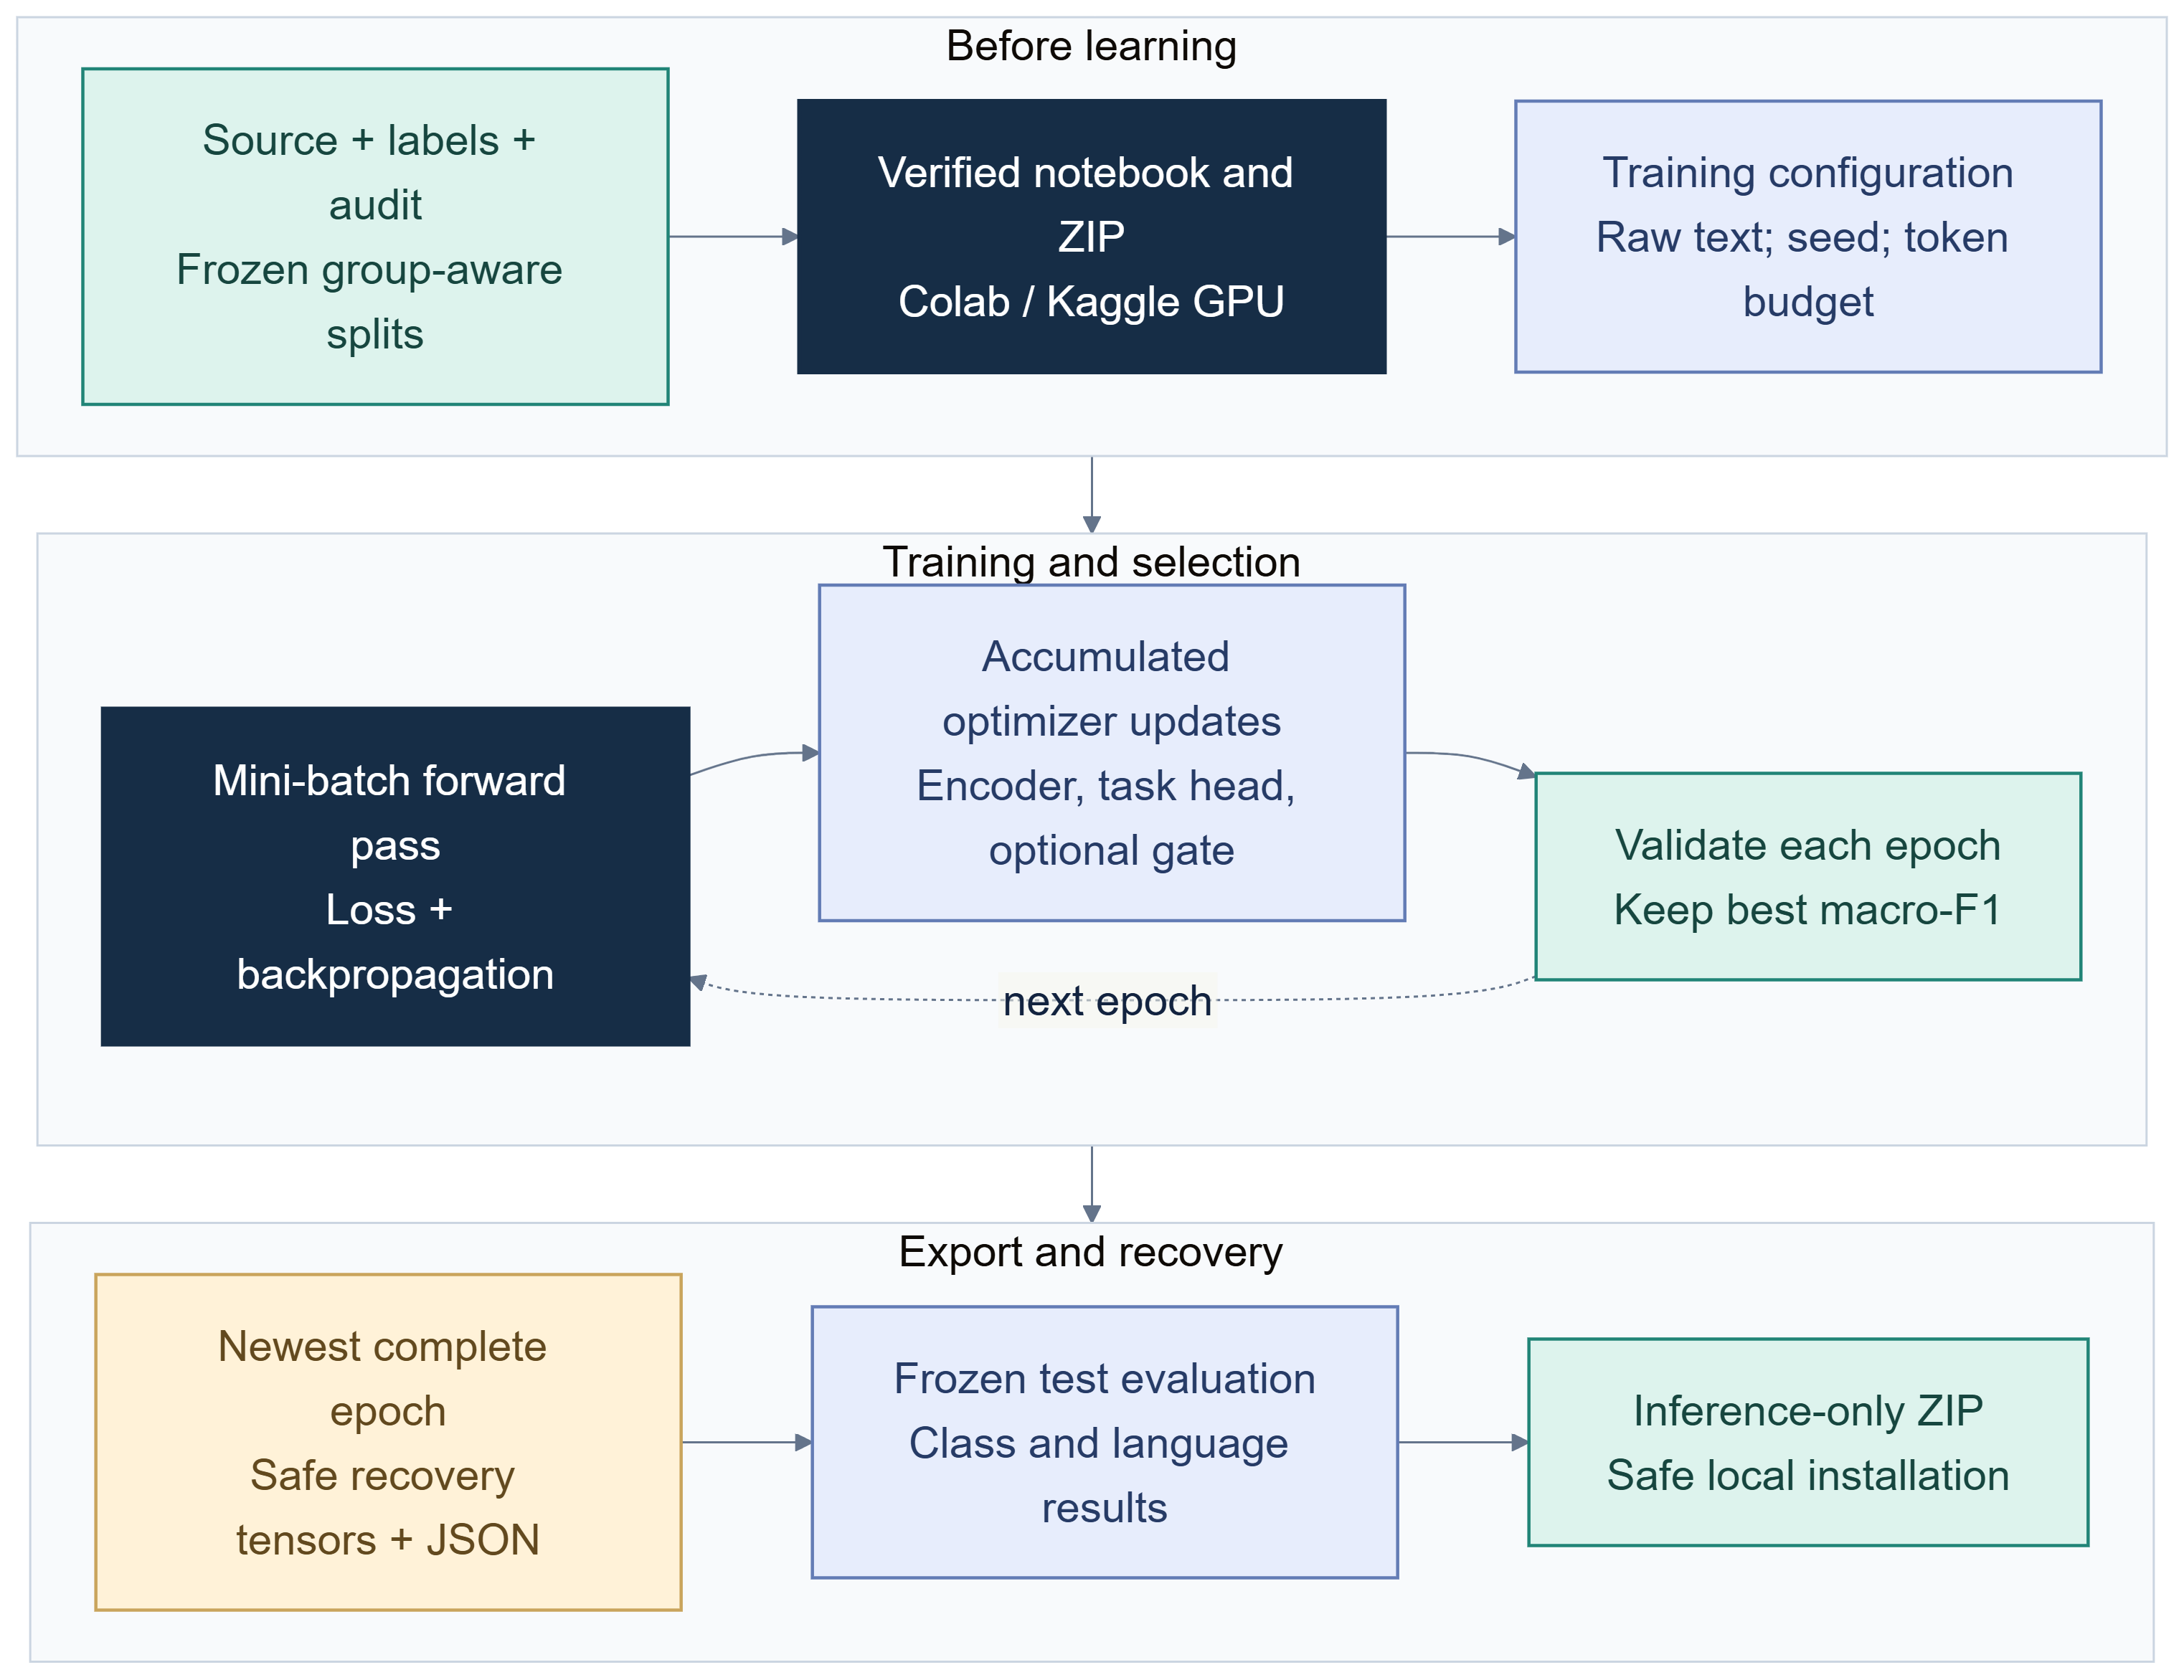
Figure 3. Cloud training, recovery and export.
The following learning curves compare validation macro-F1 across the three saved epochs. Each model selected epoch 1. The training-loss panel is shown on a logarithmic scale; its decline does not establish improvement when validation weakens.
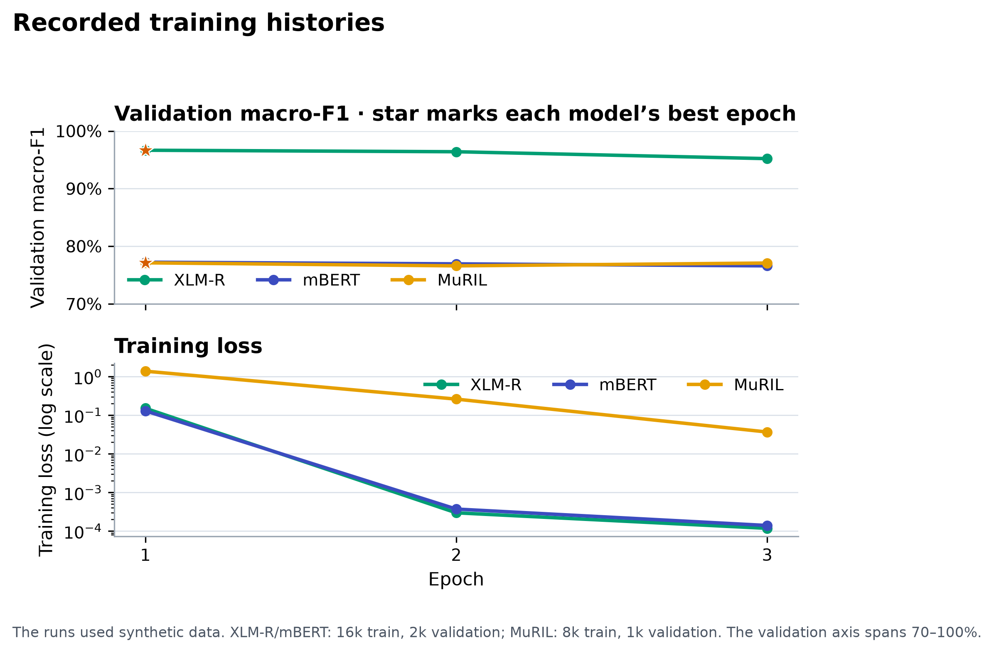
Figure 4. Recorded validation macro-F1 and training loss by epoch.
This review does not claim a new GPU run for the advanced model. Installed encoder outputs support inference and software checks; they do not imply that this machine trained the checkpoints. A future run must record input hash, split manifest, base-model revision, hyperparameters, precision, software versions, selection metric, per-class metrics and output fingerprint. Synthetic-origin training must use the explicit allow-synthetic switch and be described as experimental.

6 Model comparison
Checkpoint | Training/evaluation scope | Accuracy | Macro-F1 | Evidence status
Original XLM-R | 8k/1k/1k synthetic hi-en | 90.7% | 0.9078 | Completed synthetic run
Combined XLM-R | 16k/2k/2k synthetic, both pairs | 92.5% | 0.9251 | Completed; epoch 1 selected
Combined XLM-R, hi-en slice | Same bilingual model; 1k hi-en test rows | 95.6% | 0.9563 | Synthetic diagnostic slice
Combined XLM-R, fr-en slice | Same bilingual model; 1k fr-en test rows | 89.4% | 0.8937 | Synthetic diagnostic slice
mBERT | 16k/2k/2k synthetic, both pairs | 81.4% | 0.8119 | Completed; CPU reproduced
mBERT, hi-en slice | Same 2k test set | 84.3% | 0.8439 | Synthetic diagnostic slice
mBERT, fr-en slice | Same 2k test set | 78.5% | 0.7708 | Synthetic diagnostic slice
MuRIL | 8k/1k/1k synthetic hi-en | 80.3% | 0.8123 | Completed; different training size

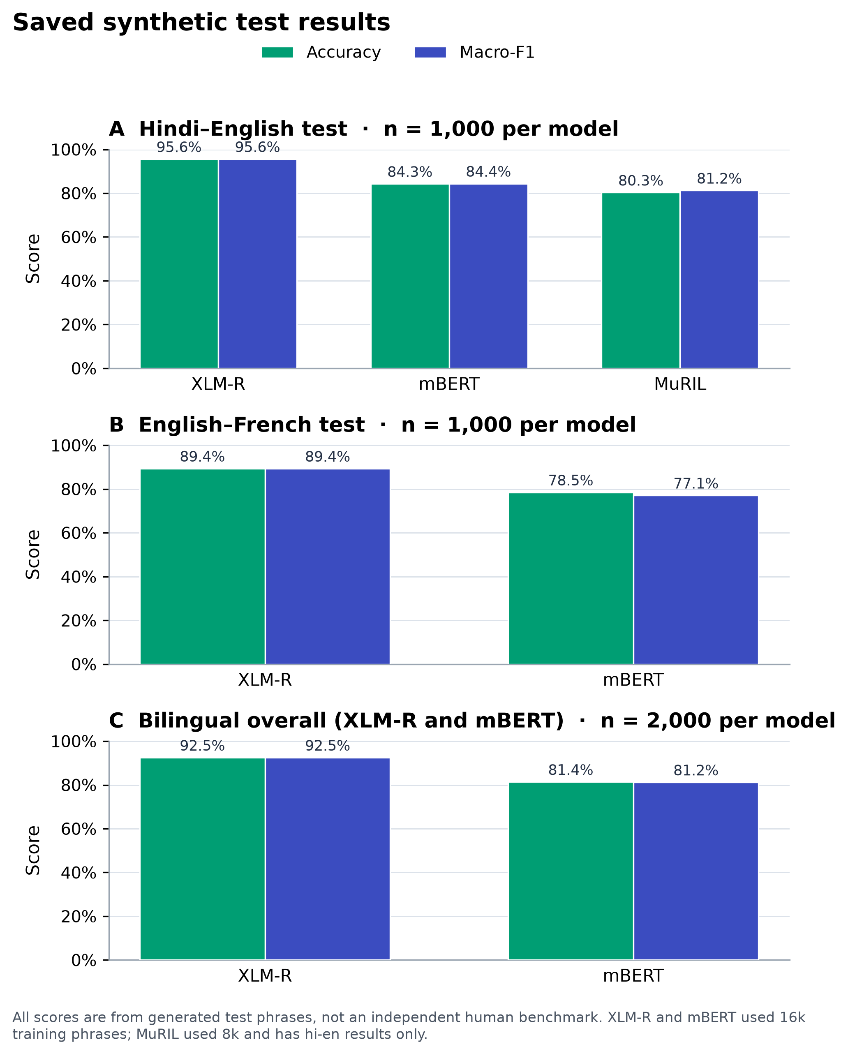
Figure 5. Checkpoint results on the saved synthetic test partitions.
The strongest recorded aggregate is combined XLM-R. These scores do not prove controlled encoder-only superiority. XLM-R and mBERT share bilingual data scale and split contract, which makes their comparison more informative, but tokenization and pretraining differ. MuRIL uses half the training examples and only Hindi-English. Combined XLM-R’s hi-en result comes from a model trained on both languages; MuRIL sees only hi-en. The supported conclusion is a lead on this synthetic setup, not universal superiority.
Accuracy is the fraction correct; macro-F1 averages class F1 equally. Neither explains which emotions fail. A future comparison should include per-class support, confusion matrices, multiple seeds and paired error review. The combined XLM-R synthetic lexical baseline is 37.55% accuracy and 0.3765 macro-F1, a reference for this generated data only.

7 Challenge diagnostics
The assistant-authored challenge drafts contain 100 Hindi-English and 100 English-French phrases. They include code-switching, negation, spelling variation, emoji, conflicting cues, indirect emotion and neutral facts. Their label column is a proposal; annotation_status is assistant_draft and human_reviewed is false. These files remain outside training and are not an independent human benchmark.
The newest diagnostic snapshot records mBERT accuracy of 50% on hi-en and 41% on fr-en challenge drafts; mBERT also scored 57.14% on the 42-row Hindi-English demo subset; MuRIL records 51% hi-en with 59.52% in the demo comparison. All labels remain assistant-authored and unreviewed. These values are diagnostics only. Their source/domain and label uncertainty prevent direct comparison with balanced generated test metrics. The exact user-reported 61% run has not been identified for this report.
The challenge results show that a model can score highly on its generator’s held-out templates and perform worse on a different assistant-written phrase set. The gap motivates independent human data and error analysis; it is not an estimate of natural-world accuracy. Natural messages may differ in author, dialect, platform, context, class prior and annotation convention.

8 File evaluation and calibration
File evaluation accepts labelled or unlabelled CSV/XLSX data, computes aggregate and per-class metrics when labels exist, and retains row predictions for inspection. When data declares a split, test scope is preferred by default. Normalized phrase hashes can identify exact overlap with saved train/validation guards. This does not detect every paraphrase, translation, shared author or template leak.
The calibration workflow fits a bounded scalar temperature on declared validation rows or a dedicated calibration file. It checks frozen train/test and evaluation phrase hashes and can require reviewed labels; synthetic and unreviewed inputs require explicit flags and remain experimental. A fitted profile is bound to model identity, preparation settings and scope. Applying temperature rescales probabilities without changing the argmax. It can change score sharpness and calibration metrics, but is not expected to improve decision accuracy by changing labels.
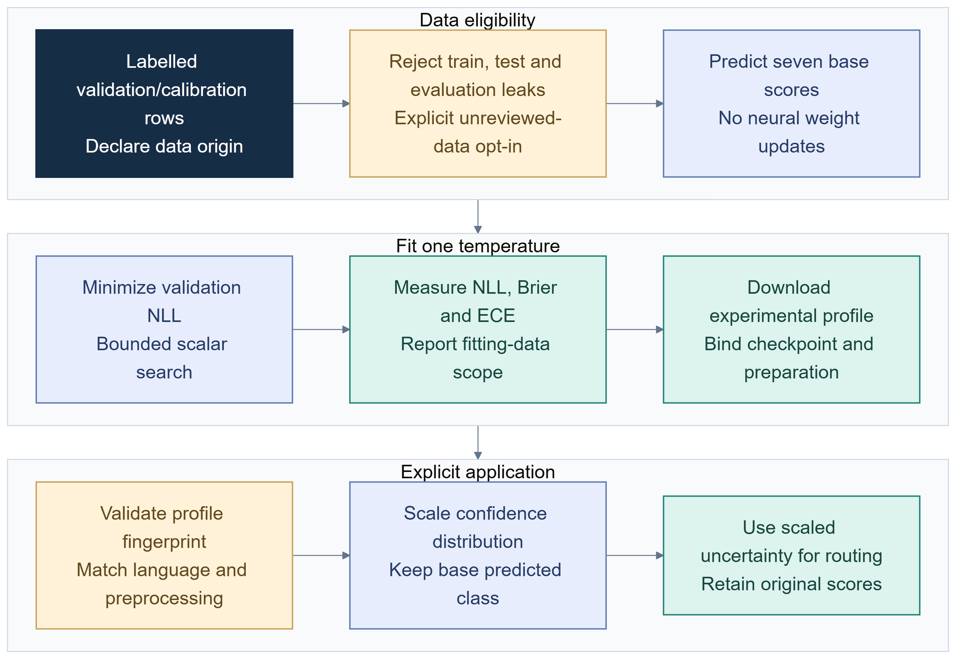
Figure 6. Calibration data to profile.
No human-labelled calibration result is reported. A software smoke check fitted one profile on a balanced subset of the existing synthetic validation data; benefit on independent reviewed data remains unmeasured. A sound report should show before/after negative log-likelihood and expected calibration error, sample count and binning, and whether rows are synthetic or reviewed. Calibration does not repair label errors or domain shift.
A measured example used 98 Hindi-English synthetic validation rows, fourteen per emotion, with frozen train/test/evaluation phrases excluded. The mBERT profile fitted temperature 2.646. These are fitting-set diagnostics, not an independent test, and classification accuracy was unchanged.
Confidence metric | Before scaling | After scaling
Negative log likelihood | 1.5044 | 0.7879
Brier score | 0.4232 | 0.3578
Expected calibration error | 0.2165 | 0.0441

9 Controlled ablation tools
The experiment runner supports baseline text, normalized text, emoji-removed text, context and no-context variants. It can also request a reviewer for every eligible row or selectively under a confidence threshold. When a split column is supplied, test rows are selected by default; a file without split declarations is treated as supplied evaluation data, without establishing independence. Variant labels are not inferred if a transformation could change the target: an explicit variant label or documented label-invariance assertion is required.
Outputs retain row identifiers, input variant, expected-label source, scores, reviewer suggestions, latency and overlap flags. This enables factor-by-factor summaries instead of a combined score. The runner cannot guarantee that an uploaded file is independently authored, balanced or correctly labelled. Dataset collection and label protocol remain central.
Ablation status: implementation exists; a reviewed, matched human run is pending. No before/after accuracy or reviewer benefit is claimed. A first study should compare raw and normalized text on the same frozen rows, then emoji retained versus removed. Context should be assessed only with authentic prior turns and an annotation protocol. Qwen modes should report quality, coverage and latency. Paired row-level transitions are more informative than unrelated aggregates.

10 Human review and correction handoff
The disagreement queue lets a human inspect model differences, then explicitly add a candidate label and notes. The new workflow generalizes this into blinded reviewer-A/reviewer-B sheets. Proposed model or assistant labels remain separate. Two reviewers provide distinct identities and canonical seven-class labels. A conflict or context flag blocks export until a distinct adjudicator supplies a label and written rationale.
Rows have a role. Training corrections are candidates for train only; evaluation rows remain test only. The workflow checks IDs, metadata, role, text, language, group policy and normalized overlap against frozen validation/test and project evaluation phrases. Completed exports bind the prepared CSV to audit and reviewer-sheet hashes. A versioned handoff keeps base validation/test partitions frozen and adds eligible corrections to train. The dashboard offers an explicit ZIP download, not an implicit write into project data.
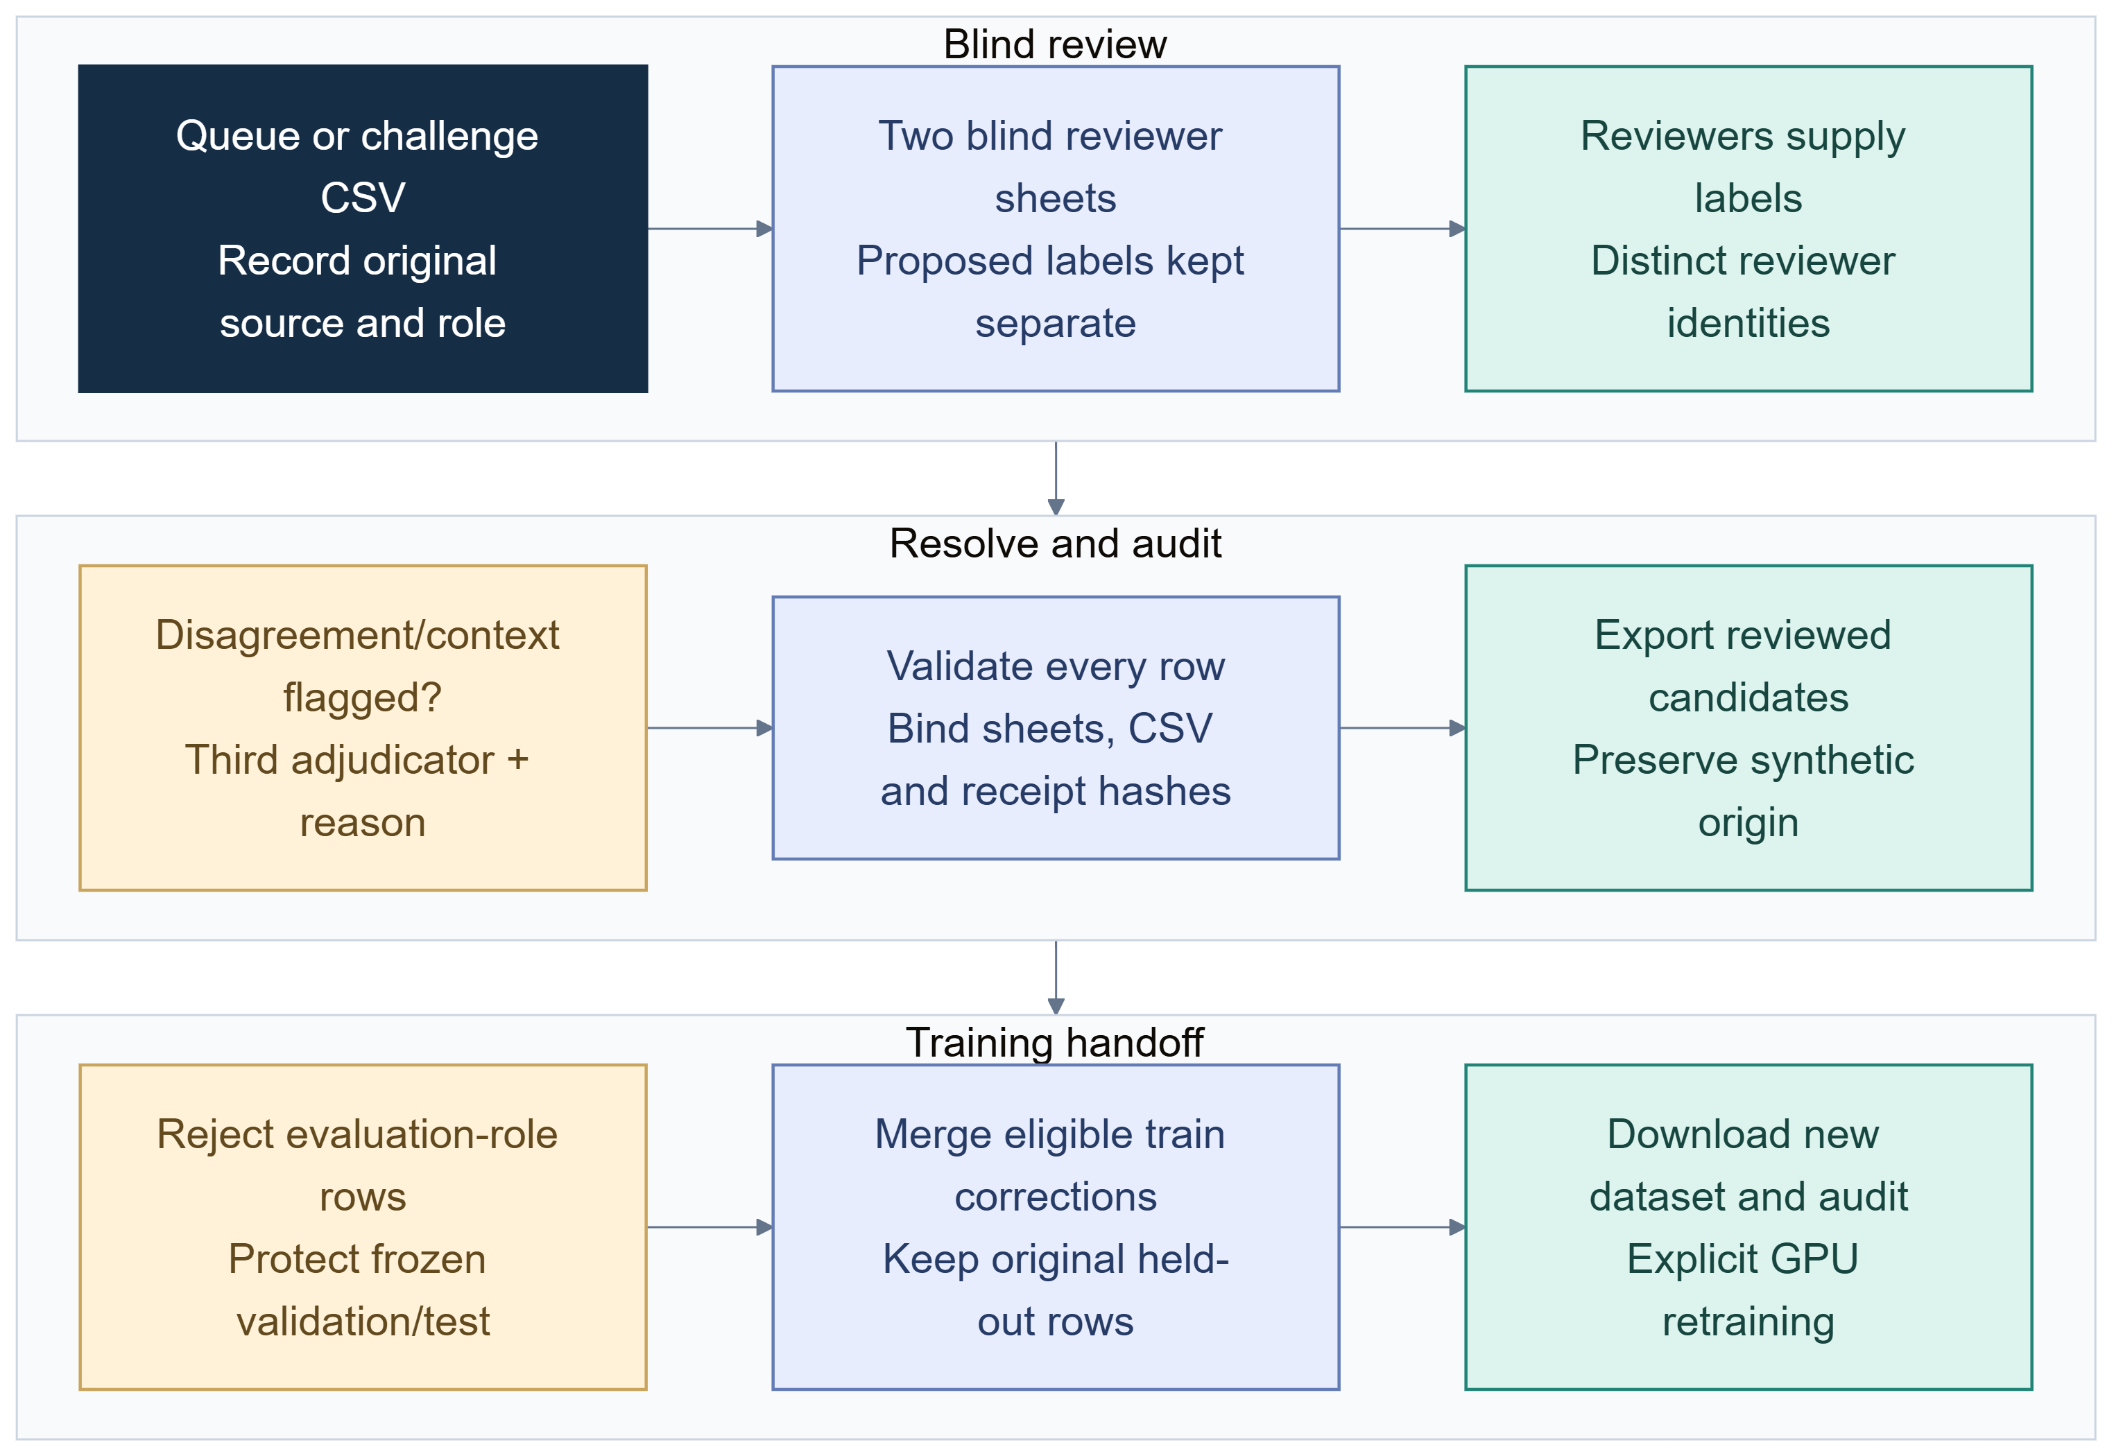
Figure 7. Human review and train-only correction loop.
This is human-controlled review, not automatic learning or active learning. The software cannot create human labels where none were entered. The review-to-GPU handoff is implemented, but no completed review sheets or resulting retrained checkpoint were supplied. Assistant-authored origin remains visible after review; synthetic-origin runs still require explicit experimental handling.

11 Advanced emoji, context and sarcasm model
The advanced trainer defines an XLM-R text encoder, learned emoji embeddings and a residual gate to combine text and emoji state. When no emoji is present, the gate is constrained to zero so emoji features do not perturb the text-only representation. Context can be supplied to the emotion encoder, and a separate sarcasm head can be trained, only when the corresponding reviewed labels are supplied. These objectives have strict split and input checks.
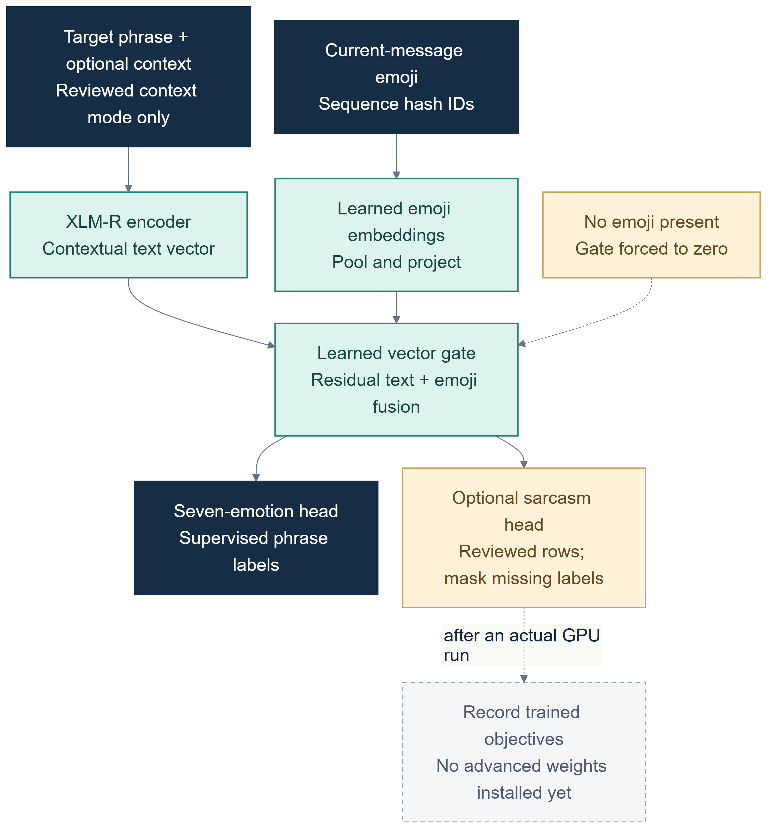
Figure 8. Advanced fusion model and training states.
The architecture is implemented; its weights are not. Default training uses emotion and emoji fusion only. Context and sarcasm remain off without suitable labels. No learned sarcasm score or emoji-fusion gain is claimed. A valid comparison would use the same examples, splits and compute budget for text-only versus text-plus-emoji, then report per-class effects. Context needs conversation-group partitions. Sarcasm labels must be independent rather than inferred from emoji or emotion. Until labels and GPU runs exist, this is an implementation option, not a research finding.

12 Feature status matrix
Capability | Status at snapshot | What can be said
Phrase/file sentiment and emotion | Implemented | Distinct three- and seven-class tasks
XLM-R, mBERT, MuRIL checkpoints | Installed; saved synthetic runs | Inference and recorded metrics reproduced within scope
Challenge drafts | Implemented; assistant-authored | Diagnostic fixtures only, labels unreviewed
Model disagreement | Implemented | Sequential outputs and explicit human queue
Temperature calibration | Implemented | Profile fitting/application; human benefit unmeasured
Input/reviewer ablations | Implemented | Controlled runner; reviewed results pending
Conversation trace | Implemented | Bounded phrase analysis with supplied context
Blind review and dataset handoff | Implemented | No human labels supplied; no new dataset
Text/emoji fusion | Implemented, untrained | No advanced checkpoint or measured gain
Context mode and sarcasm head | Optional and label-gated | No reviewed task labels or trained weights
New GPU retraining | Pending | Capability exists; no new run completed

The matrix describes a snapshot, not a production-readiness claim. UI controls and module tests establish software paths, not model validity. Pending status should change only when a reproducible artifact or verified dataset supports it.
The distinctions also help reviewers interpret the repository as a compiler-design project. The application accepts text and structured files, validates schemas, normalizes selected input forms, routes requests by task and language, invokes a model adapter, then serializes results with warnings and provenance. Model packages carry task labels and preprocessing metadata, so routing can reject incompatible artifacts. Dataset preparation and split manifests are separate from the inference path. This modular pipeline is a systems result even when the scientific evidence remains limited. Its interface makes the boundary visible: a fallback demo is labelled as such, a missing trained checkpoint does not trigger an implicit download, and a review candidate does not mutate weights.
The interface is not itself a quality guarantee. A dashboard screenshot can demonstrate that a workflow is reachable, while an integration test can show that the app routes a request and handles an error. Neither substitutes for independent labels. Likewise, the presence of a model card or dataset audit improves reproducibility only insofar as its hash points to the artifact and its claims match the underlying source. This review uses the saved artifacts and explicitly labels assistant-draft diagnostics to avoid converting an implemented screen into an unsupported performance statement.

13 Risks and responsible use
Emotion prediction interprets text; it does not access a writer’s internal state. It should not be used for diagnosis, discipline, hiring or other consequential decisions. Code-mixed spelling and dialect are normal language variation. Context may change interpretation; phrase models can miss speaker, quotation, irony and referent. A high score is not certainty about a person’s feelings.
Privacy depends on the data path. Local encoder inference keeps text on the machine, while optional Ollama receives supplied text through a local service. Exports and reports should minimize personal information and respect source terms. Public-corpus reuse remains subject to its conditions; unresolved reuse should block export. Challenge drafts remain marked unreviewed.
The strongest current contribution is systems integration and evidence traceability: metadata-aware inference, task separation, reproducible splits, explicit scope, guarded evaluation and human-controlled export. The project should not claim a novel emotion theory, Emoji2Vec reproduction, reliable sarcasm detection or external validity. Stating limits is useful because it defines what current artifacts can support.

14 Next study and GPU plan
The next study starts with annotation, not another model. Define the target as expressed emotion or perceived emotion. Write guidance for mixed affect, neutral statements, quoted speech, negation and sarcasm. Collect consented or properly licensed examples, recording provenance and groups. Use two independent annotators, measure disagreement, adjudicate under a documented protocol, and reserve a frozen group-disjoint test set. Keep assistant-authored challenge material separate until reviewed.
Then run a matched comparison. Train XLM-R, mBERT and eligible MuRIL on the same supported rows and splits, with a predeclared tokenization policy, compute budget and selection metric. Repeat seeds where possible. Report accuracy, macro-F1, per-class support, confusion, language slices, uncertainty intervals where feasible, runtime and failure examples. Separate calibration rows from test. Add raw/normalized, emoji-retained/removed and context/no-context ablations one factor at a time.
The existing synthetic emotion dataset can exercise experimental text/emoji fusion now. Reviewed context and sarcasm labels are required before enabling those additional objectives. The cloud default is 16k/2k/2k multilingual emotion-only supervision; context and sarcasm remain off. The correction handoff can add reviewed training rows without changing frozen validation/test. Report mixed synthetic/human composition and use the explicit synthetic switch when needed. No advanced GPU training is complete in this snapshot.
Before launching a long run, retain a compact experiment manifest containing the exact code revision, dataset and audit hashes, split-manifest hash, base encoder identifier, tokenizer version, text-preparation mode, seeds, batch and accumulation settings, learning rate, maximum length, precision, early-stopping rule and selected epoch. Record the runtime provider and GPU model because a cloud notebook session can change availability and speed. Save validation traces and recovery state at epoch boundaries, but never use test metrics to select a checkpoint. At completion, install the exported checkpoint in a clean local environment and replay the exact held-out file to confirm that packaged inference reproduces the saved evaluation. If a dependency or model artifact cannot be resolved, report that as a blocked run rather than filling the gap with an unverified result.
The study should predeclare which comparisons are primary. For example, the first human-data result could be a single text-only encoder against a lexical baseline on a frozen group-disjoint test set. Extra languages, calibration, reviewer assistance and multimodal fusion can follow as separate questions. This order helps avoid a situation where many options are tried on one small test set and only the most favorable score is reported. It also makes a negative outcome useful: if emoji removal does not hurt or improves performance, the conclusion should reflect the observed data rather than the expected design benefit.

15 Conclusion, references and validation
CodeMood now combines four multilingual checkpoints, separate sentiment and emotion workflows, file diagnostics, experimental calibration, controlled ablation software, bounded conversation analysis and a human review-to-training handoff. The completed model lead is combined XLM-R on generated data. The mBERT checkpoint’s saved metrics were reproduced on CPU. Assistant-written challenge diagnostics show that scores can fall on a different phrase set, but those labels remain unreviewed and do not quantify natural-world accuracy.
The supported conclusion is bounded: the repository demonstrates a working local research and deployment pipeline and completed synthetic experiments. It does not yet demonstrate robust human-authored Hinglish accuracy, learned sarcasm, calibrated human-test confidence, reviewer benefit or advanced fusion gain. Human annotation and controlled GPU experiments are the next evidence-producing steps.
Final validation record: The complete offline suite passed 221 tests and 33 subtests. A separate integration check exported a tiny fixture through the SafeTensors installer and local fusion adapter, while tests verified emoji gate gradients, forced zero contribution without emoji, masked missing sarcasm labels, target-first context tokenization, scalar calibration, review leakage guards and backward-compatible baseline inference. The advanced training dry-run verified 16,000/2,000/2,000 partitions and zero reviewed context/sarcasm rows. Both GPU notebooks compile, and their package includes source/data hashes. No full advanced GPU training, independently reviewed dataset or measured fusion gain is claimed. Existing mBERT inference reproduced its 2,000-row synthetic test result.

References
- Team 5 – G2. Lexical and Emoji-Dependent Emotion Detection Using Contextual Text Reference in English-Hinglish Code-Mixed Data. Supplied course report; cited scores not independently reproduced.
- Conneau et al. “Unsupervised Cross-lingual Representation Learning at Scale.” ACL 2020. https://arxiv.org/abs/1911.02116
- Khanuja et al. “MuRIL: Multilingual Representations for Indian Languages.” 2021. https://arxiv.org/abs/2103.10730
- Devlin et al. “BERT: Pre-training of Deep Bidirectional Transformers for Language Understanding.” NAACL-HLT 2019. https://aclanthology.org/N19-1423/
- Liu et al. “RoBERTa: A Robustly Optimized BERT Pretraining Approach.” 2019. https://arxiv.org/abs/1907.11692
- Eisner et al. “emoji2vec: Learning Emoji Representations from their Description.” SocialNLP 2016. https://aclanthology.org/W16-6208/
- Encoder cards: XLM-R https://huggingface.co/FacebookAI/xlm-roberta-base ; mBERT https://huggingface.co/google-bert/bert-base-multilingual-cased ; MuRIL https://huggingface.co/google/muril-base-cased .
- Google Colab FAQ, runtime resources and limits. https://research.google.com/colaboratory/faq.html
- Repository references: training/calibrate.py, hinglish_emotion/calibration.py, training/run_experiments.py, hinglish_emotion/experiments.py, training/review_workflow.py, training/train_advanced.py and training/WORKFLOW.md.
Reviewer identifiers are a consistency check; the team remains responsible for ensuring that two independent people actually provide the reviews.

